**Civey Methodology**

- It's a unique methodology. Most nonprob panels recruit via advertisements on social media or sponsored google search results, whereas Civey recruits by putting single questions within news articles

Source: <https://civey.com/unsere-methode>

1. Respondents for the panel are recruited on various new websites via short surveys that are imbedded in the articles. After responding, they are asked to register for the panel.
   * Civey claims that they can recruit people with various characteristics and Interests, by including their recruitment surveys in articles on various different webpages and on different topics.
2. Respondents have to provide their basic demographic characteristics and data processing response, in order to be put into the sample. They verify respondents through technical, statistical, and content plausibility checks.
3. An algorithm draws quoted samples from all surveys from the verified responses. In addition to quoting sociodemographic data, such as gender or age, the algorithm ensures that any potential content bias in the vote is balanced.
   * Surveys that are shown to a user via the recommendation algorithm are included in the sample.
   * Responses to a survey that are directly embedded in an article are generally not considered due to the potential for content influence.
4. Demographic imbalances are eliminated using survey statistical methods. Weighting is done either with the marginal distributions or through common distributions (post-stratification). To determine regional results, small area methods with multilevel regression with poststratification are used.

**Example for recruitment in Focus online article**

<https://www.focus.de/politik/deutschland/auf-letzter-pk-grinst-habeck-schelmisch-und-packt-unter-applaus-grafik-aus_788edbbd-9718-4042-b315-7a57d65c9f2d.html>

1. Single question inserted into a news article:

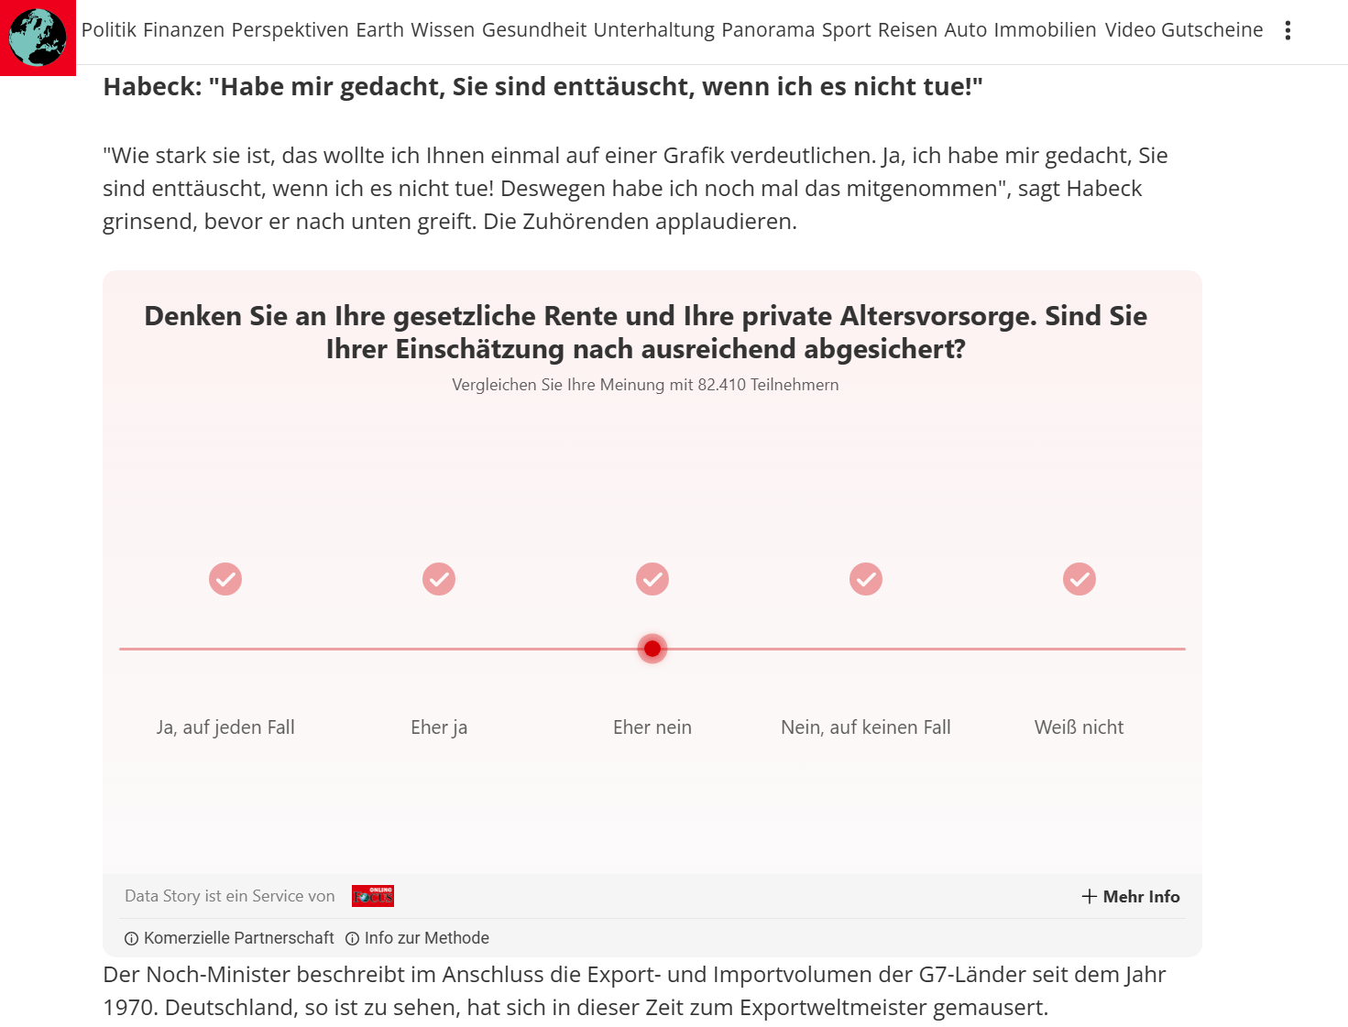

1. Short popup after response

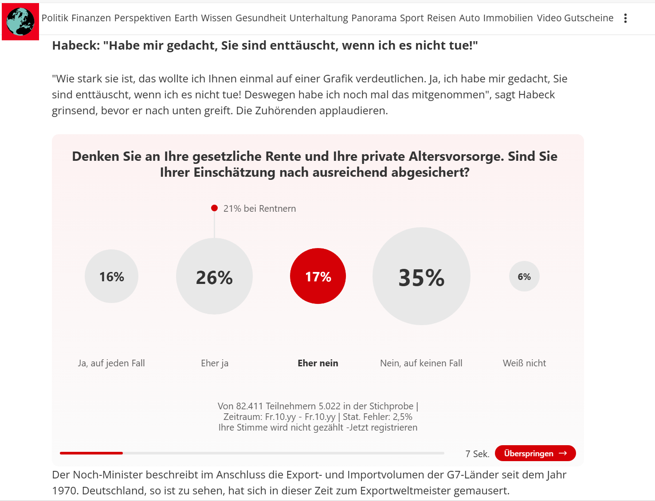

1. Question to sign up for Focus online Newsletter

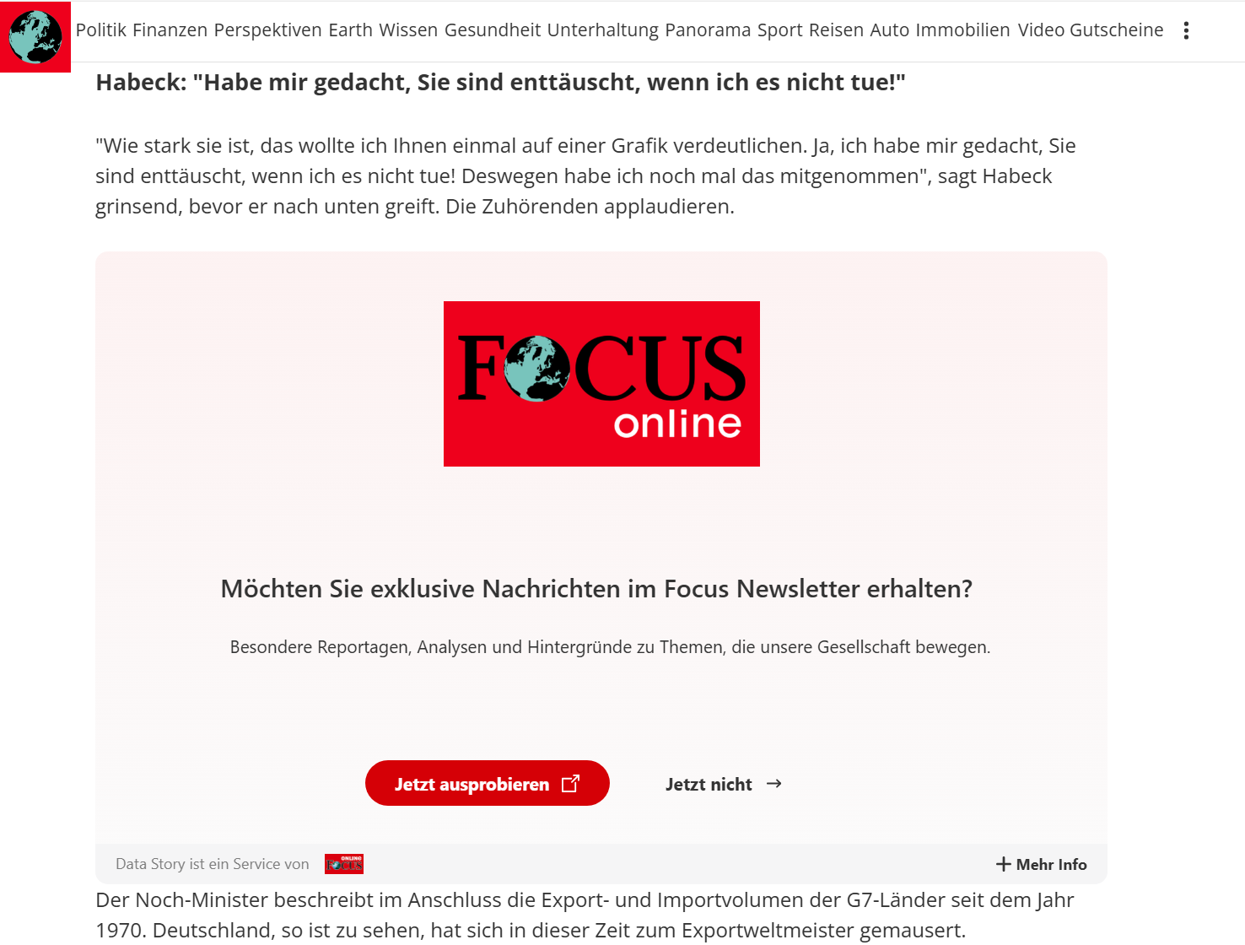

1. Forwarding to survey

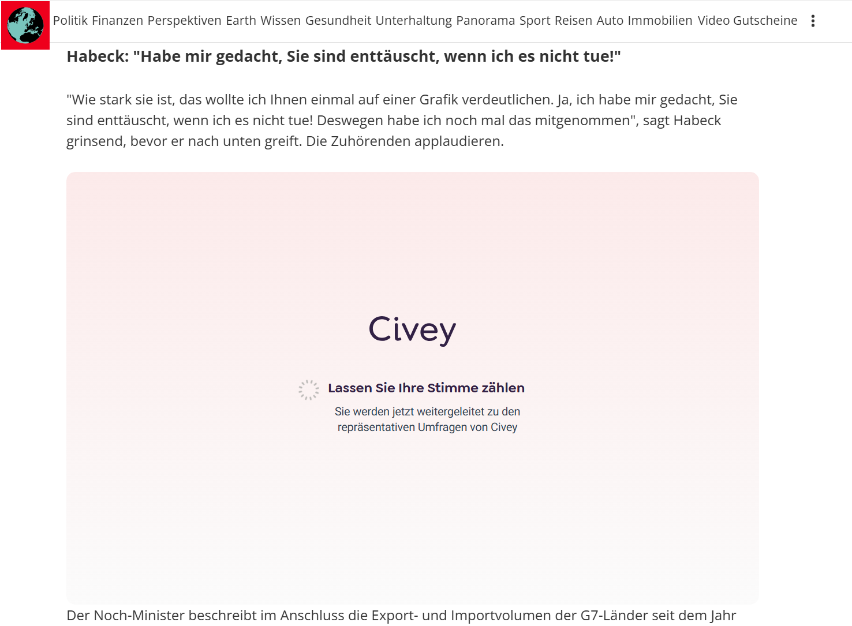

1. Question about marital status

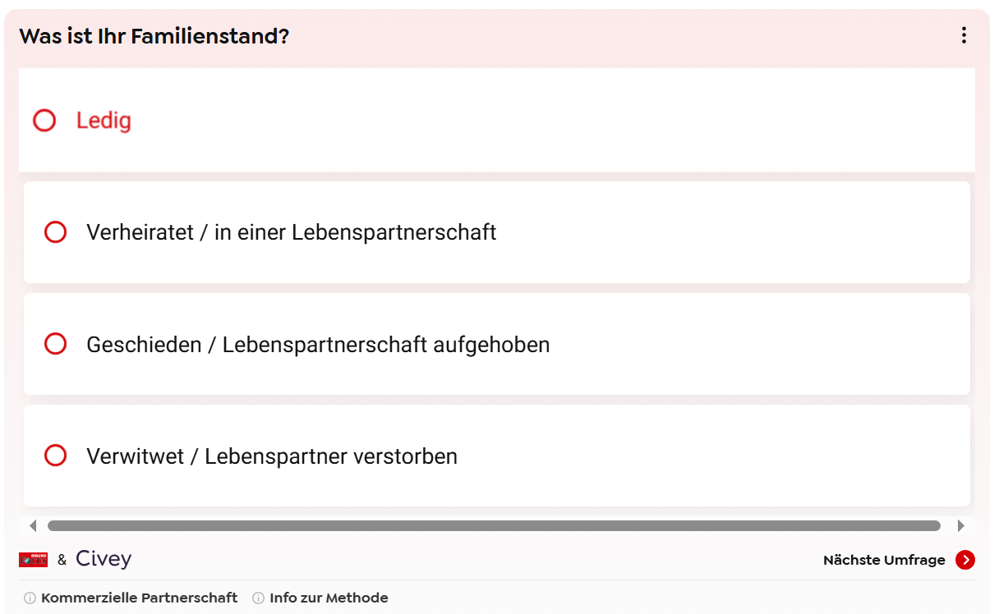

1. Aks to provide information on the questions required to get for representative results.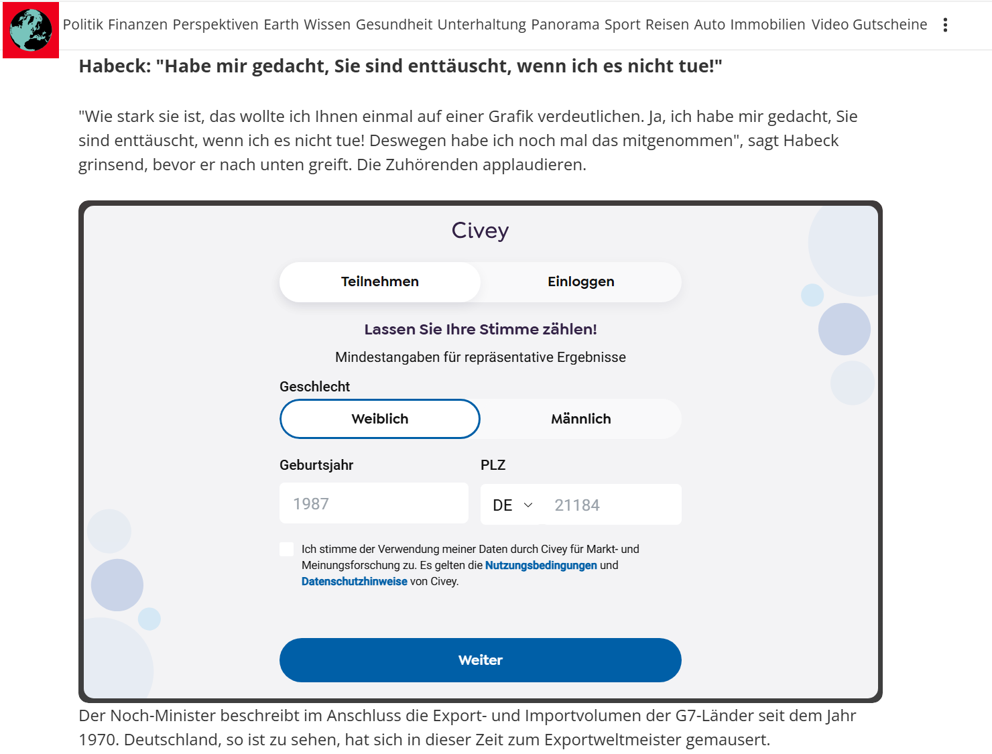
2. Further questions are presented

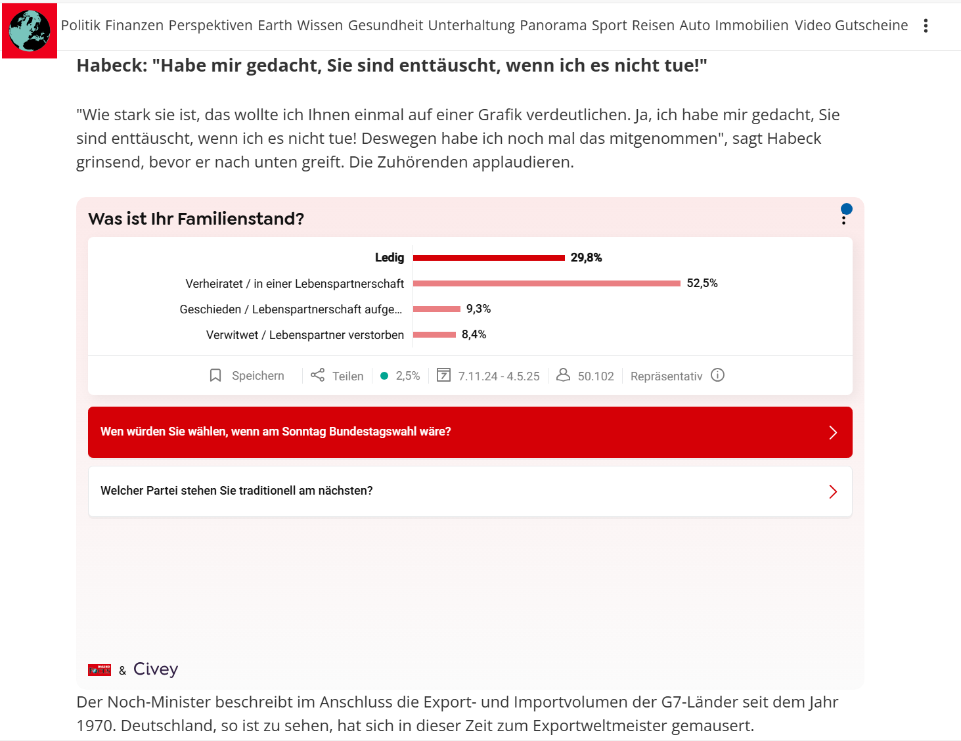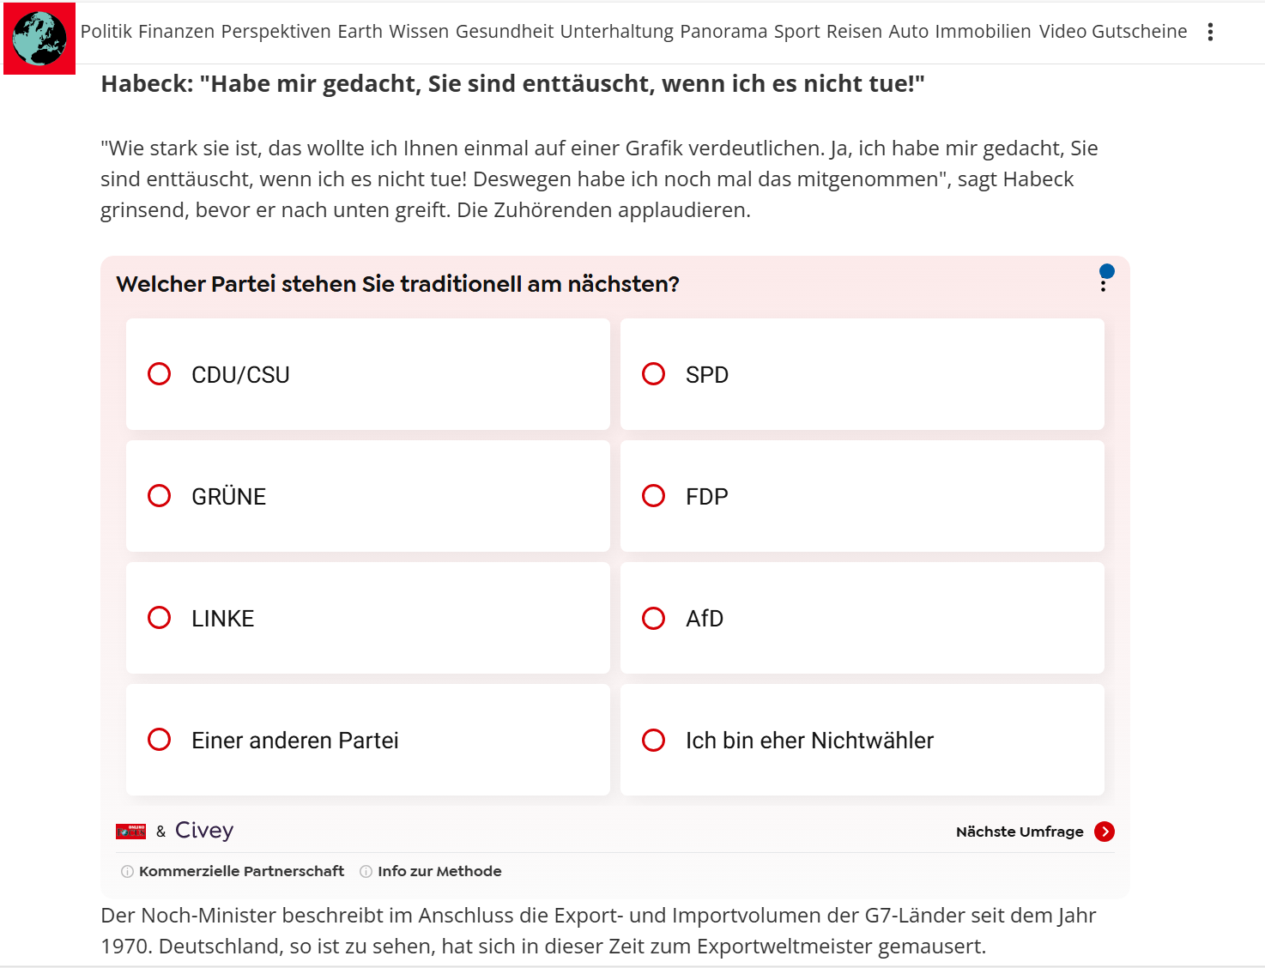

1. After the respondents answered one of the further questions, they ask them to register with an email address

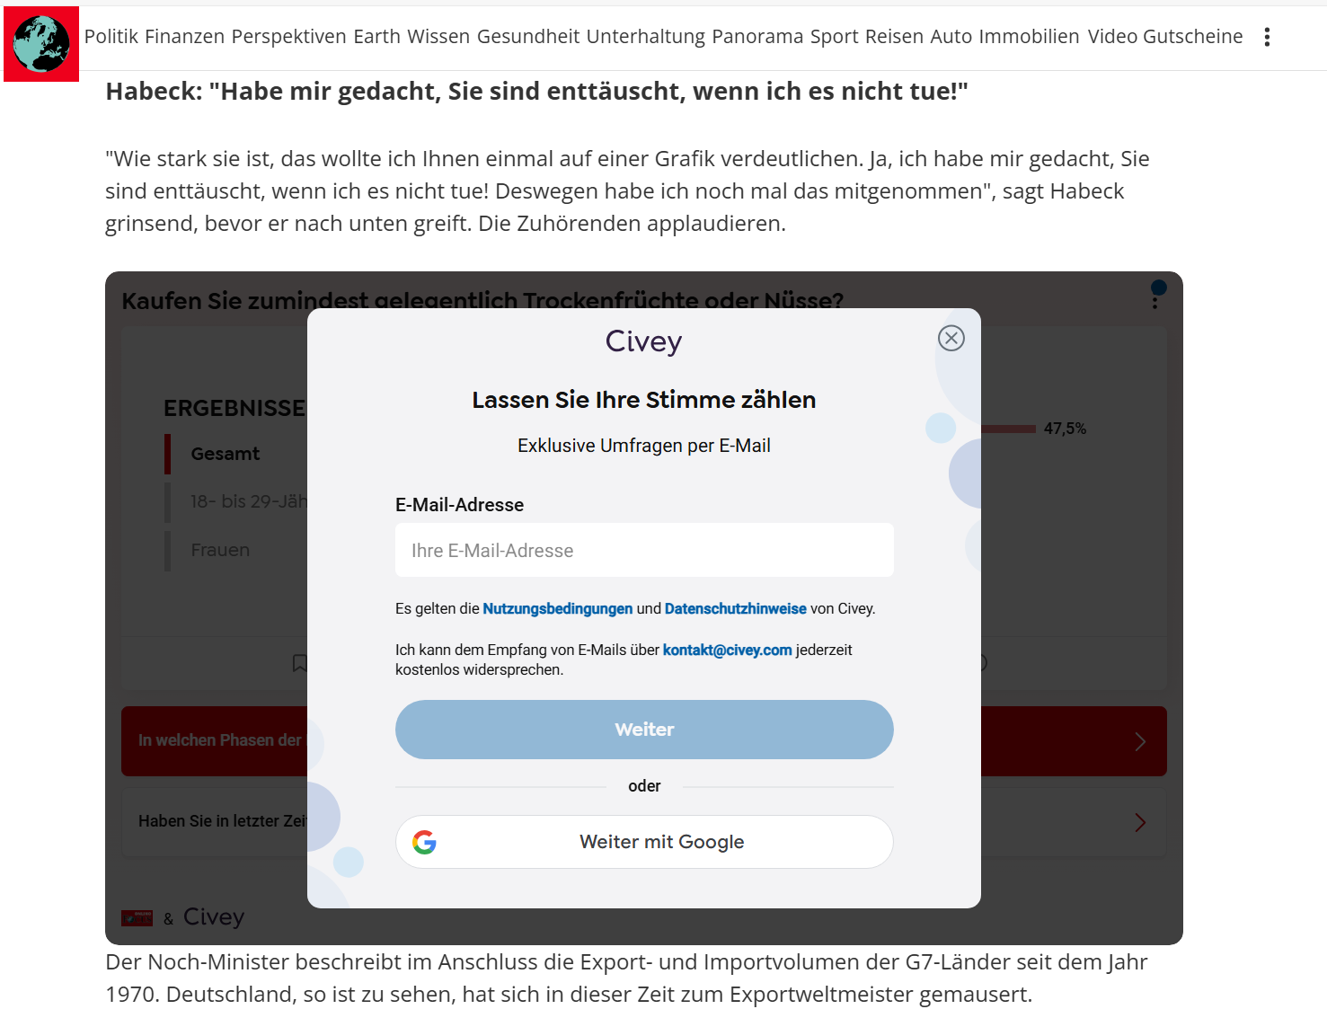

Information under Info-Button “Kommerzielle Partnerschaft” & “Info zur Methode

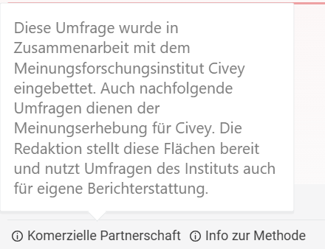 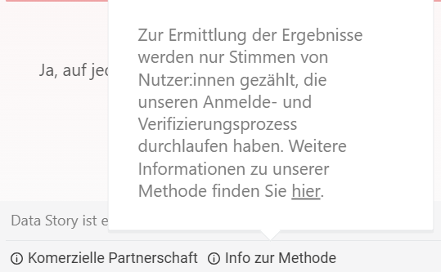

**How does Civey prevent manipulation and distortion of results?**

Source: <https://civey.com/hilfe/user/methodik/wie-verhindert-civey-manipulation-und-verzerrung-von-ergebnissen>

* Claim to have technical control mechanisms against the risk of targeted manipulation of the results
  + verifies responses based on technical, statistical, and content criteria, including participation speed and content plausibility, or contradictions in given responses
* To ensure that they reach enough people from all demographics, the surveys are integrated into several thousand websites of various online media every month.
* only the votes of registered users are considered in the analysis
* Clicks on the first embedded survey in an article are generally not considered for the sampling, because depending on which article a survey is embedded on, the reader may be directed in a certain direction by the context on the article